BINGO Night

Saturday June 24th at 6:30 PM
Clubhouse
Come join this fun game of chance and test your luck.
Cost is $5.00 per bingo card
BYOB & bring snacks to share.

CLICK HERE for more details or contact Daphne Blauser at kblauser@hotmail.com

Bike Club

Sunday June 25th at 9:00 AM
Clubhouse

Meet at the Clubhouse and then drive to the Regal River Point Movie parking lot:
3565 South Platte River Drive
Sheridan, Colorado 80110 DIRECTIONS

This week’s bike ride will be on the Bear Creek Bikeway and is approximately 16 miles roundtrip. We will ride to the Fox Hollow Golf Course and have lunch at The Den at Fox Hollow before riding back to the Regal River Point Movie parking lot.

Contact Reina Bernfield reinascopes@gmail.com

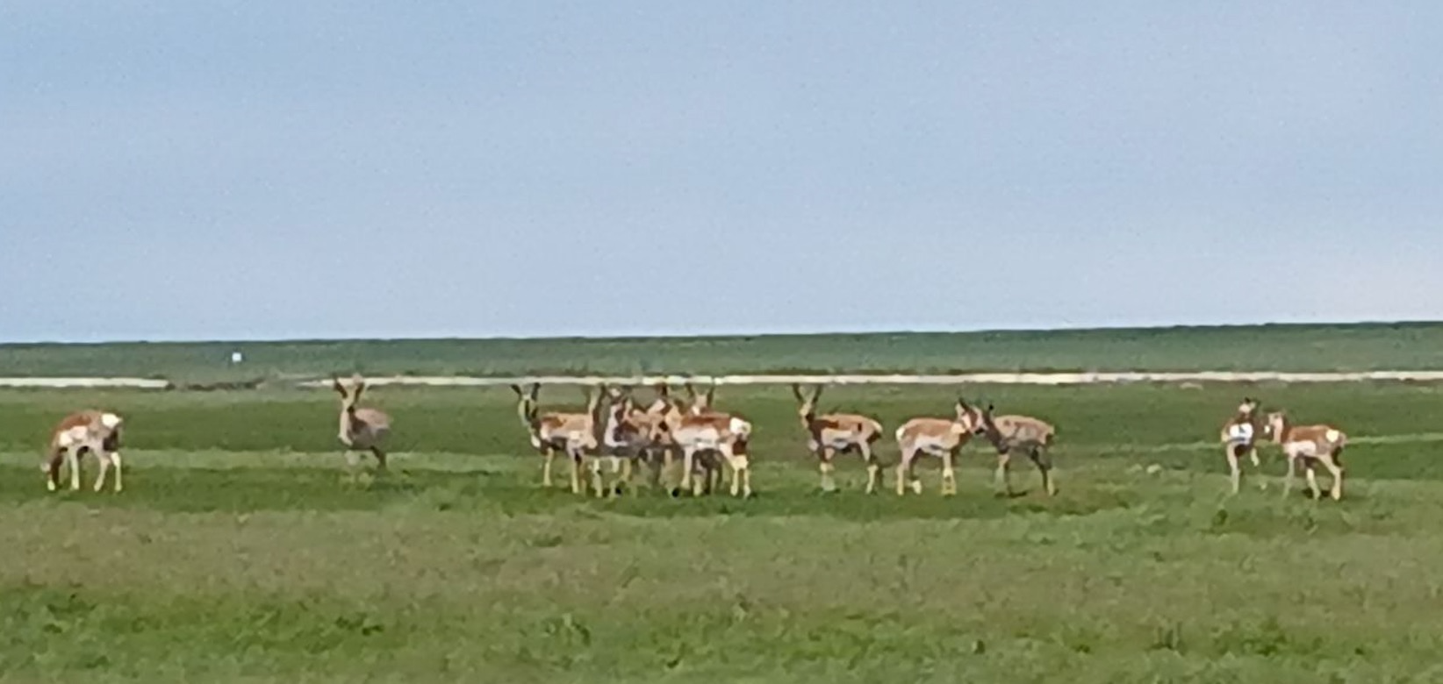

Photo from last week’s ride on the bike path along E470 to the Southland Mall. Even though riders were in the middle of highways, neighborhoods and retail space, there is so much beauty and wildlife all around us!

Chair Massage with Jerry

Tuesday June 27th 3:00 – 6:00 PM
Clubhouse

Get rejuvenated and schedule a 20-minute session, for only $25. CLICK HERE

Creative Endeavors
Draped Concrete Pots

Thursday June 29th 10:00 – Noon
Clubhouse

Jean Close will be teaching and assisting all in making their own unique draped concrete pot.

Please plan to bring a piece of material, 3’ x 3’ (tablecloth, curtain, towel, fleece blanket, linen napkins or lace doilies of any color or pattern).
All other supplies will be provided.

For more details & to sign-up CLICK HERE

Volunteers Needed
Jack Sargent & Josie Nolan are looking for volunteers to help with the 4th of July Parade or Cookout. They only need an hour or two of your time and you will still be able to enjoy the celebration.

If you are interested CLICK HERE to sign-up.
Clubhouse

Gina Blakewell, Interim Lifestyle Director
Office Hours 9 AM – 5 PM Mon. – Fri.
info@theclubatfv.com | 303.307.4719

Gina will be on vacation the week of June 26^{th.}
We will have others covering normal office hours during that time.

Office Closed – Mon. July 3rd & Tues. July 4th.

Fourth of July Celebration
Parade, Sing-along, & Cookout

The 4th of July Parade, Sing-Along, & Cookout has been an annual event in our community since 2020.

Tuesday July 4th
Clubhouse
RSVP

Please get signed up TODAY!

9:30 AM Parade staging at Lodge
10:00 AM Parade starts at Lodge and
ends at the Clubhouse
11:30 AM Sing-along starts
12:30 PM start enjoying the Cookout

Please bring a Lawn Chair or two.

We are looking for volunteers to help with the parade or cookout. An hour of two of help with greatly be appreciated. Please CLICK HERE to sign up.

Community Advisory Committee (CAC) Meeting
Clubhouse Multipurpose Room

Saturday July 8th at 10:00 – 11:30 AM
The meeting can be attended in person or on a Zoom call. More details and the Zoom link will be sent to all residents prior to the meeting.
Second Annual Visual Arts Show
Showcasing the talents of some of our Fairway Residents

Saturday, August 26, 2023
Noon to 3:00 PM
Clubhouse

SAVE THE DATE – more details to come!

Fairway Residents and their guest are welcome to attend.

If you would like to be an exhibitor to showcase your art/craft and/or be a part of the planning stages of this event, please contact either Susan or Jean at:
Susan Cotter - svhcotter@gmail.com
Jean Close - jedaclose@yahoo.com

7th Annual Gezzer Gulch Scramble

Tuesday, September 5, 2023
GVR Golf Course & Clubhouse
8:30 AM – 11:00 AM Tee Times
4:00 PM Picnic Dinner at the Clubhouse (significant other or spouse welcome to attend the picnic dinner).

SAVE THE DATE – more details to come

Geezer Gulch will be 15 teams of 4, for a total of 60 available spots.

There will be a $20 (per person) Entry Fee:
- Used to pay for awards and a donation.
- Please make check payable to "Bruce Michalowski" and give to Gina at the Clubhouse Office.

NOTE: Vouchers, Passes, & Discounts cannot
be used or applied.
- $77 = Non-Members Including Carts
- $52 = Members without Cart Pass
- $ 0 = Members with Cart Pass

Work Order Request

Please continue to submit work orders if you see something that needs attention, repaired, or replaced. This includes inside or outside both the Clubhouse or Lodge, pools, hot tub, pickleball court, bocce ball court, and landscaping.

The form is easy to use and you can even upload photos. It really helps the SDM to manage everything when the below workorder form is completed and submitted.

CLICK HERE to submit a workorder.

Many times, a CAC member or Gina hear about issues, but yet no workorder was ever submitted. Please take a few minutes to submit a workorder, and you will find you will get faster results.

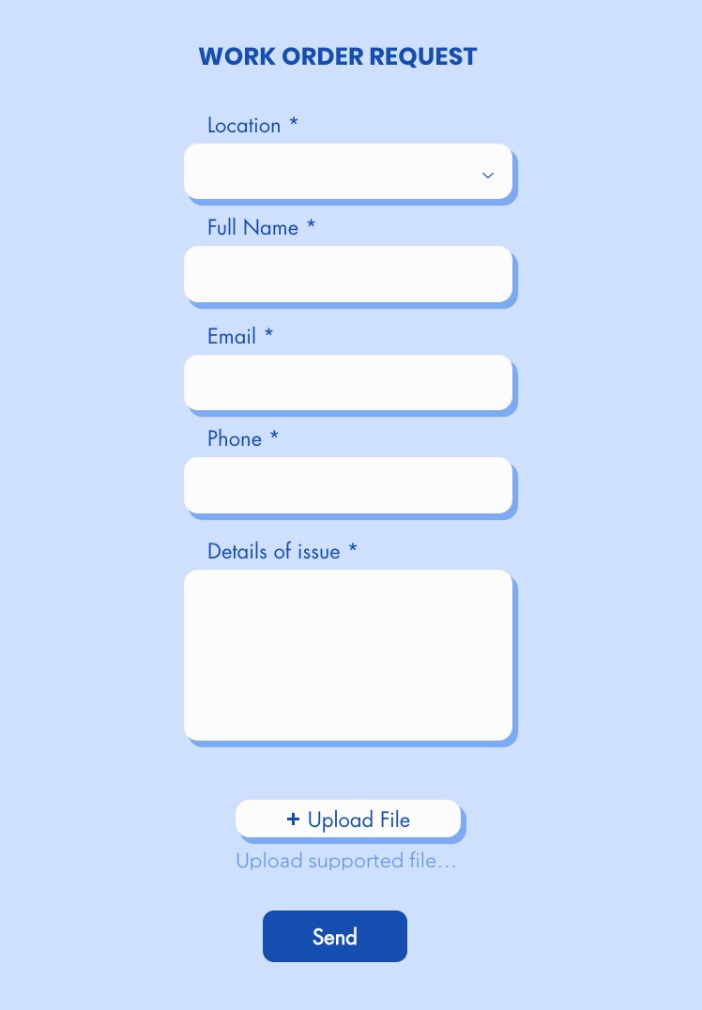

Flags for Community Flag Poles

You may have noticed the flags are down. They were getting pretty tattered and we are working to order new ones in time for the 4th of July Celebration.

Clubhouse Lights

Those organizing evening activities or card games, etc. Please remember to turn off the lights when you leave. Thanks!

